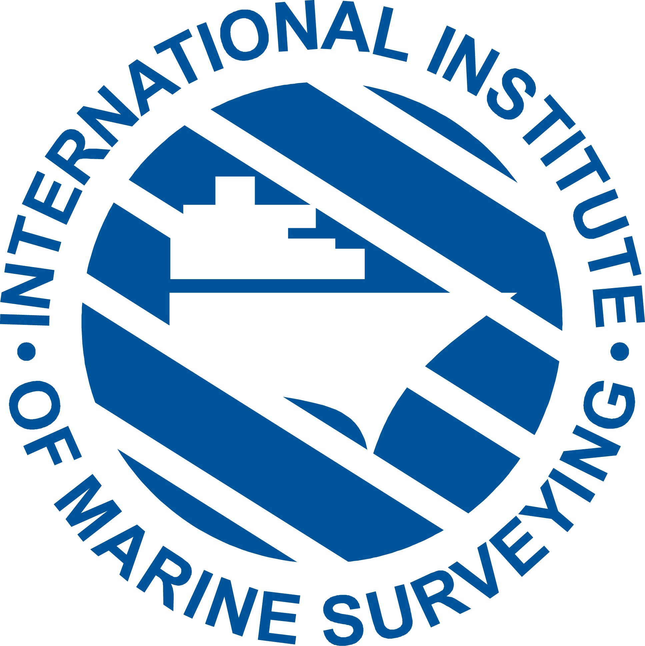 |  | 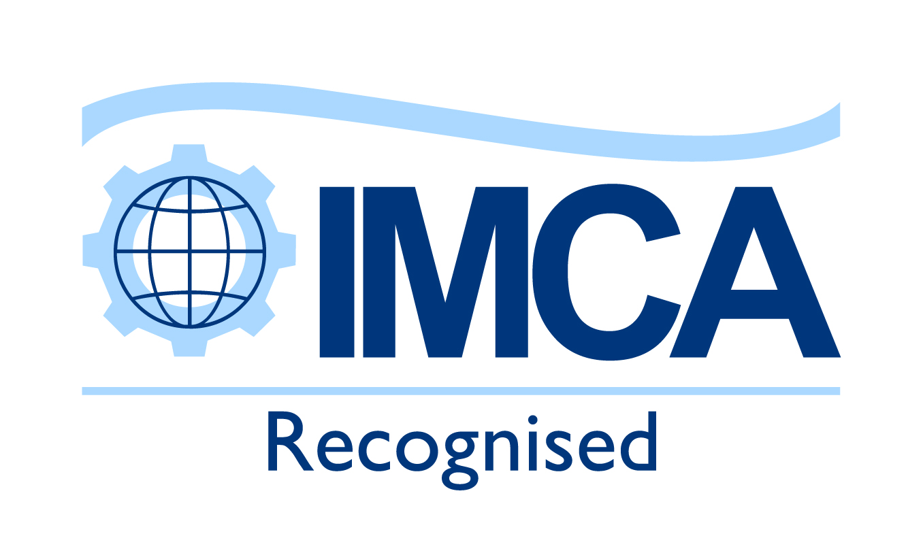

cmid vessel inspector accreditation application form
MARINE SURVEYING ACADEMY Ltd  Administration Office  Murrills House, 48 East Street, Portchester,  Hampshire PO16 9XS | Issued: / / FOR OFFICE USE ONLY
 | Received: / / Number:
 | CMID Assessor comments

I | YOUR PERSONAL DETAILS
Forenames (BLOCK CAPITALS): |  | Family Name (BLOCK CAPITALS):
Titles, Decorations, Honours etc. (not your qualifications):

Nationality: |  | Date of Birth:
Correspondence Address: |  | Phone No (Country/area code):  Email Address:
Present Employer’s Name and Address (if any): |  | Phone No: (Country/area code)  Email Address:
What is your current job title (if appropriate):

CREDENTIALS SECTION – MAXIMUM 40 POINTS

II | EDUCATION & QUALIFICATIONS
Secondary School: |  | From | To | Years | Examinations Passed:
College/Polytechnic/University: |  | From | To | Years | Marine Qualification/Degree/Diploma & Subject:
Membership of Professional Institutions/Associations: |  | From | To | Years | Grade of Membership:
Other Relevant Courses or Qualifications: |  | From | To | Years | Certificate/Diploma:

III | YOUR EMPLOYMENT HISTORY
From  Month/Yr |  | To  Month/Yr | Company Name and Address | Position(s) (state whether as an employee or self employed)
NB: Please ensure you submit a copy of your current CV with your application

IV | YOUR CMID EXPERIENCE
Approximately how many CMID’s have you completed (place an ‘x’ in the appropriate box)?
1 - 10 11- 25 26 - 50 51 - 100 Over 100

V | VESSEL TYPE ENDORSEMENTS YOU ARE SEEKING TO BE ACCREDITED FOR AND  YOUR SUPPORTING EVIDENCE IN WHICH YOU CLAIM RELEVANT EXPERIENCE
Mark with ‘x’ | Vessel Type | Please describe in several sentences what experience you have in the vessel type(s) you are seeking accreditation for in the appropriate box(es) below. The onus is on you to provide sufficient information for the Accreditation Assessor to make his objective judgement that you have the relevant experience. Please be as concise as possible.  Please submit 2 CMID inspection reports, (unless you are a new inspector), for each vessel type below you are seeking to be approved for.
 | General vessels
 | LNG fuelled vessels
 | Jack-Up vessels
 | Heavy Lift vessels
 | DP vessels
Pipe & Cable
Laying vessels
Marine Inspection
of Small Workboats

VI | COMPETENCE: SAFETY  SAFETY SECTION TOTAL – MAXIMUM 50 POINTS
If your CV does not provide sufficient evidence, please describe in several sentences in the box below what experience you have to satisfy the Accreditation Assessor that you have the necessary competency in the area of safety. Give examples if you wish. The onus is on you to ensure the Accreditation Assessor has sufficient information to make his objective judgement that you have the relevant experience.

As a guideline, consider how you raise concerns when observing or identifying non-compliance that may affect the safety of personnel/environment and how you complete all elements of ISM and HSE sections of the inspection accurately and correctly.

VII | COMPETENCE: AUDIT, INSPECTION AND ADMINISTRATION  AUDIT INSPECTION SECTION TOTAL – MAXIMUM 60 POINTS
If your CV does not provide sufficient evidence, please describe in several sentences what experience you have to satisfy the Accreditation Assessor that you have the necessary competency in the area of audit, inspection and administration. Give examples if you wish. The onus is on you to ensure the Accreditation Assessor has sufficient information to make his objective judgement that you have the relevant experience.

For example, how do you plan an audit/inspection and carry out common audit/inspection processes and procedures? How do you collect objective audit evidence and verify its accuracy and ensure the inspection is meaningful and comprehensive. Explain how you gain subjective evidence and information by talking to appropriate crewmen and how and provide the Master with the opportunity to comment on findings before leaving the vessel. Explain how you apply audit/inspection principles, procedures and techniques and conduct the audit/inspection and submit reports in appropriate formats and so on.

VIII | COMPETENCE: TECHNICAL AND OPERATIONAL  TECHNICAL AND OPERATIONAL SECTION TOTAL – MAXIMUM 40 POINTS
If your CV does not provide sufficient evidence, please describe in several sentences in the box below what experience you have to satisfy the Accreditation Assessor that you have the necessary competency in the area of technical and operational. Give examples if you wish. The onus is on you to ensure the Accreditation Assessor has sufficient information to make his objective judgement that you have the relevant experience.

For example, you may wish to consider how you conduct an inspection of one of the vessel types you are seeking approval for, demonstrate that you understand the major specialist features of the vessel and its equipment and explain how to articulate specific technical issues coherently and accurately.

IX | COMPETENCE: COMMUNICATION AND INTERPERSONAL SKILLS  COMMUNICATION AND INTERPERSONAL SKILLS TOTAL – MAXIMUM 50 POINTS
If your CV does not provide sufficient evidence, please describe in several sentences in the box below what experience you have to satisfy the Accreditation Assessor that you have the necessary competency in the area of communication and interpersonal skills. Give examples if you wish. The onus is on you to ensure the Accreditation Assessor has sufficient information to make his objective judgement that you have the relevant experience.

As a guideline, you may want to consider how you communicate effectively with all parties to complete audits, how you act as lead auditor and how you communicate audit findings to interested parties.

X | REFERENCES
1. Name and Address  Telephone:  Email: |  | 2. Name and Address  Telephone:  Email:
I CONFIRM THAT I HAVE CONTACTED THE REFEREES WHO HAVE AGREED TO ACT ON MY BEHALF

XI | DECLARATION
The CMID Vessel Inspector Code of Conduct has been written specially with CMID Vessel Inspectors in mind. The basic principles of the CMID Vessel Inspector Code of Conduct can be found online at: http://cmidvesselinspectors.com/code-of-conduct.

To view the Data Protection Policy to understand how we use your personal data, see online at: http://cmidvesselinspectors.com/contact/data-protection-policy.
DECLARATION. I agree that in the event that I am accredited as a CMID Vessel Inspector I will be governed by the Code of Conduct and will advance the objects of the accreditation scheme as far as shall be in my power. I understand I may withdraw from the scheme at any time and that I need to notify the International Institute of Marine Surveying Academy in writing if I choose to do so and that no part of my fee will be refunded to me. I confirm I have read and understand the obligations above. My signature herewith indicates acceptance of them.

I DECLARE THAT THE STATEMENTS MADE BY ME ON THIS FORM AND ANY ATTACHMENTS ARE CORRECT

FULL NAME DATE

Please make your application by email to: hilary.excell@marinesurveyingacademy.com or by post to: Marine Surveying Academy Ltd,
c/o International Institute of Marine Surveying, Murrills House, 48 East Street, Portchester Hampshire, PO16 9XS, United Kingdom.
CMID Vessel Inspector Accreditation Application Check List
- Completed Application form
- Copies of attested certificates
- One passport size photograph with your signature on the back
- Confirmation that you have informed your referees
- Current curriculum vitae (cv)
- Accreditation fee of £395 (this must accompany your application – see payment instructions below)
- Ensured that you have signed the declaration
- Any other supporting documentation you feel to be relevant
FOR OFFICE USE ONLY
ASSESOR’S COMMENTS ONLY

This applicant meets the necessary criteria and is approved for accreditation 

This applicant does not currently meet the required standard for accreditation 

Signed: …………………………………………………………… Print name: …….......................................…… Date: ………………………………….…

XII | YOUR PAYMENT INSTRUCTIONS FOR ACCREDITATION
The cost of accreditation is £395 which must be paid before your assessment begins.

There are three options.

Option 1

By credit or debit card (only Visa and MasterCard accepted). If you wish to use this option please contact us.

Option 2
Bank address:
Lloyds
20-24 High St
Gosport
PO12 1DE
By direct bank transfer to:
PLEASE PUT IN
YOUR SURNAME
AS YOUR REFERENCE

Marine Surveying Academy Ltd
Lloyds Bank Sort Code: 30-93-56
Account Number: 39136560
IBAN Number: GB15LOYD30935639136560
BIC/SWIFT Code: LOYDGB21292

Option 3
By cheque (made payable to Marine Surveying Academy Ltd) and returned with this form by post to:

Marine Surveying Academy Ltd.
Murrills House, East Street, Portchester, Hampshire,
PO16 9XS, United Kingdom.

A receipt for your payment will be sent to you.

